**Dashboard of Credit Card Transaction Report**

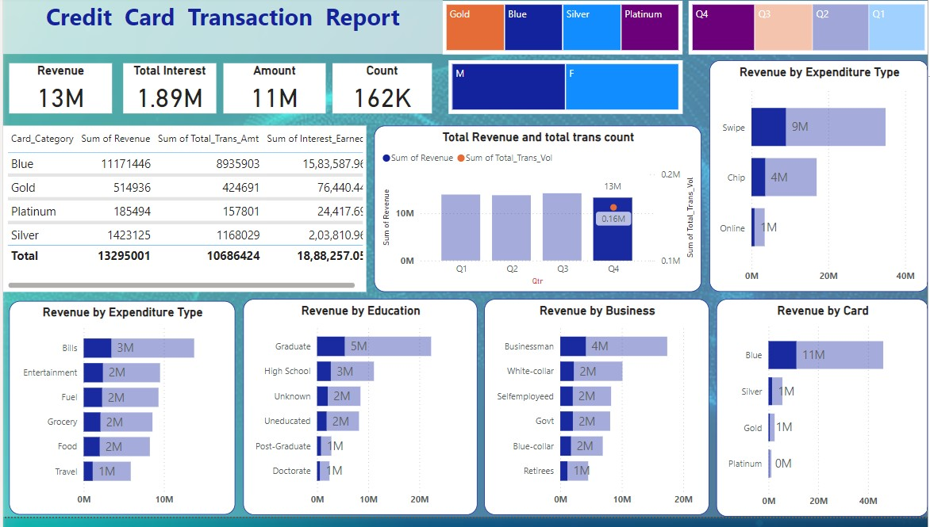

**Insights from the Credit Card Transaction Report Dashboard**

1. **Overall Revenue and Transactions**:
   * **Total Revenue**: ₹13 Million (M).
   * **Total Interest Earned**: ₹1.89M.
   * **Total Transaction Amount**: ₹11M.
   * **Total Transaction Count**: 162K.
2. **Revenue by Card Category**:
   * **Blue Card**: Dominates the market with a revenue of ₹11.17M, contributing significantly to the total revenue.
   * **Silver Card**: Generates ₹1.42M in revenue.
   * **Gold Card**: Brings in ₹514,936 in revenue.
   * **Platinum Card**: Generates the least revenue, ₹185,494.

**Interest Earned**:

* + **Blue Card**: ₹15.83M, the highest among all categories.
  + **Silver Card**: ₹2.03M.
  + **Gold Card**: ₹76,440.
  + **Platinum Card**: ₹24,417.

1. **Quarterly Performance**:
   * Revenue remains consistent across Q1, Q2, and Q3 at approximately ₹13M.
   * A slight decline in Q4 with revenue still at ₹13M, but a notable decrease in transaction volume (0.16M).
2. **Revenue by Expenditure Type**:
   * **Swipe Transactions**: Contribute the most, ₹9M in revenue.
   * **Chip Transactions**: Generate ₹4M in revenue.
   * **Online Transactions**: The least, with ₹1M in revenue.
3. **Revenue by Consumer Type**:
   * **Education Level**:
     + Graduates are the highest contributors, generating ₹5M in revenue.
     + High School, Uneducated, and those with Unknown education levels each contribute ₹2M.
     + Post-Graduates and Doctorates generate ₹1M each.
   * **Business Type**:
     + Businessmen contribute ₹4M, the highest in this category.
     + White-collar workers, Govt employees, Blue-collar workers, and the self-employed generate ₹2M each.
     + Retirees contribute ₹1M.
4. **Gender Distribution**:
   * The dashboard shows a significant difference in usage between males and females, with males dominating the transactions.
5. **Revenue by Specific Expenditure**:
   * **Bills**: Generate the highest revenue at ₹3M.
   * **Entertainment, Fuel, and Grocery**: Each contribute ₹2M.
   * **Food**: Generates ₹1M.
   * **Travel**: Also brings in ₹1M.
6. **Revenue by Card Type**:
   * **Blue Cards**: Again, dominate with ₹11M in revenue.
   * **Silver, Gold, and Platinum Cards**: Each contributes less, with Silver and Gold at ₹1M, and Platinum near zero.

**Summary**

The Blue Card is the top-performing card across all categories, with Swipe transactions and Businessmen as key contributors to the overall revenue. Revenue from the educational and occupational segments indicates that Graduates and Businessmen are prime customers. Online transactions and Platinum Cards underperform, indicating potential areas for growth or reconsideration in business strategy. The dashboard highlights a strong male dominance in credit card usage.